Ideation Phase
Define the Problem Statements

Date | 18 June 2026
Team ID
Project Name | SHOPEZ : E-commerce Application
Maximum Marks | 2 Marks

Customer Problem Statement :
A problem statement captures the customer's point of view so the team can stay focused on what truly matters to them. For ShopEZ, the statements below describe the frustrations faced by busy shoppers and by sellers who manage their own listings, framed in the customer's own voice.

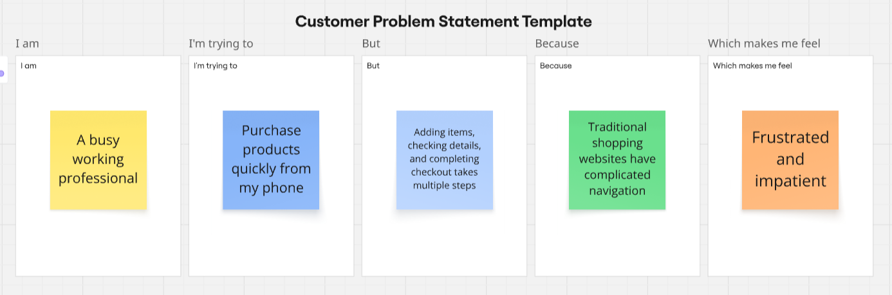

Problem Statement (PS) | I am (Customer) | I'm trying to | But | Because | Which makes me feel
PS-1 | A busy working professional | buy a specific gift quickly from one trusted site | I have to compare prices and items across many tabs and stores | products, reviews and discounts are scattered and hard to filter | Overwhelmed and short on time
PS-2 | A first-time online shopper | check out and pay without creating risk | I am unsure whether my account and payment details are safe | many sites have unclear sign-in and confusing checkout flows | Anxious and hesitant to complete the order
PS-3 | A small seller / store admin | list products and track incoming orders in one place | I cannot easily update stock, prices or order status | there is no single dashboard that shows products and orders together | Frustrated and out of control of my own catalogue

